# 

|  |  |
| --- | --- |
|   **PREDICTING AND CLASSIFYING H1-B VISA APPLICATION STATUS** |  |

# 

**CONTENTS**

INTRODUCTION 3

MOTIVATION AND PROBLEM STATEMENT 3

DESCRIPTION OF DATASET 4

DATA PRE-PROCESSING 5

EXPLORATORY ANALYSIS 6

DATA MINING METHODS 11

6.1 MODELS WITH ORIGINAL DATASET 12

6.1.1. KNN 12

6.1.2. CLASSIFICATION TREE 13

6.1.3. LOGISTIC REGRESSION 16

6.1.4. NEURAL NETWORK 18

6.2 MODELS WITH UNDERSAMPLED DATASET 19

6.2.1. KNN 20

6.2.2. CLASSIFICATION TREE 20

6.2.3. LOGISTIC REGRESSION 22

6.2.4. NEURAL NETWORK 24

COMPARISON OF MODELS 24

CONCLUSION AND RECOMMENDATION 26

FUTURE WORK 27

REFERENCES 27

# **INTRODUCTION**

The US H1-B visa is an employment-based non-immigrant visa that allows US companies to employ graduate level workers in specialty occupations that require theoretical or technical expertise in specialized fields such as IT, finance, accounting, architecture, engineering, mathematics, science, medicine, etc. Foreign workers fill a critical need in the U.S. labor market—particularly in the Science, Technology, Engineering, and Math (STEM) fields. Every year, U.S. employers seeking highly skilled foreign professionals submit their petitions for the pool of H-1B visa numbers for which U.S. Citizenship and Immigration Services (USCIS) controls the allocation. With a low statutory limit of visa numbers available, demand for H-1B visa numbers has outstripped the supply in recent years, and the cap has been reached quickly. Research shows that H-1B workers complement U.S. workers, fill employment gaps in many STEM occupations, and expand job opportunities for all.

This report demonstrates methods that can be used to statistically predict the outcome of H-1B applications before they are submitted to the USCIS. It highlights the relationships between different attributes, and examines them visually through use of charts. In addition, experiments are performed with a variety of data mining models and techniques and finally this report recommends a model to predict an application’s outcome as approved or denied.

# **MOTIVATION AND PROBLEM STATEMENT**

More than 50% of graduate students in STEM university programs are foreign students. They are the direct beneficiaries of the H1-b visa category which is specially designed for non-immigrant workers. As foreign students ourselves, we can relate to the challenges of getting an approved H1-b visa. For this project, we put ourselves in the role of a data analyst for a visa/immigration consultancy firm and attempted to create a machine learning model which could accurately predict the outcome of an application based on its attributes. This analysis will help foreign students and job seekers gain better insight of different factors that affect the Visa Application approval or denial. The main focus of the project is to find an algorithm that can accurately classify the denied visa applications, and subsequently prevent the loss of money to application fees.

Using various tools, we will be able to analyze and explain the following questions:

* Explore how different variables interact with CASE_STATUS approval
* Distribution of applications across regions based on prevailing wages
* Recommend clients whether the application will be APPROVE/DENIED

# **DESCRIPTION OF DATASET**

**Data Set:** h1b_kaggle.csv

**Source:** <https://www.kaggle.com/nsharan/h-1b-visa>

The data used for the project has been picked from the Kaggle website. The raw data has been imported from The Office of Foreign Labor Certification (OFLC) website and a set of data transformations were performed to make the data more accessible for quick exploration.

This dataset contains five years’ worth of H-1B petition data. The dataset has **3,002,458** rows and **11** variables over years 2011 to 2016. It includes the following attributes.

* **X:** Unique identifier assigned to each application submitted for processing.
* **CASE_STATUS:** Status associated with the last significant event or decision. Valid values include “Certified,” “Certified-Withdrawn,” Denied,” and “Withdrawn”.
* **EMPLOYER_NAME:** Name of employer submitting labor condition application.
* **SOC_NAME:** Occupational name associated with the requested job under temporary labor condition. Standard Occupational Classification system defines the codes and the names associated with them.
* **JOB_TITLE:** The requested job title in the petition.
* **FULL_TIME_POSITION:** Y = Full Time Position; N = Part Time Position
* **PREVAILING_WAGE:** Prevailing Wage for the job being requested for temporary labor condition.
* **YEAR:** Year when petition is filed (in between 2011-2016).
* **WORKSITE:** The address of the employer worksite.
* **Lon:** Longitude of the employer worksite.
* **Lat:** Latitude of the employer worksite.

# **DATA PRE-PROCESSING**

The raw data contains 6 years’ worth of data (2011-2016) which amounts to over 3 million records. Data is filtered out for the year 2016 for ease of analysis. Before preprocessing and data cleaning, our truncated dataset contains **647,803** records.

The percentage of missing values (N/A) is approx **2.7%** of records. These values have been excluded from the analysis as they can't be handled with any random values.

The outcome variable to be predicted is CASE_STATUS. The project tries to establish the dependency of the decision of CASE_STATUS on the attributes of the application. The existing distribution of different status labels in 2016 data is as follows.

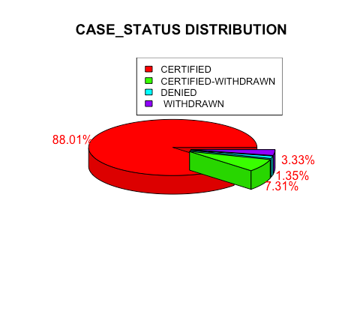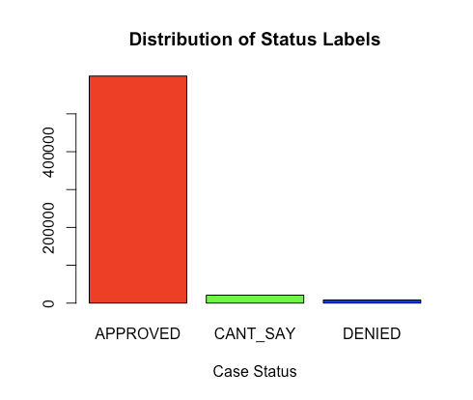



The aim is to predict the case decision as either "APPROVED" or "DENIED". Records are re-labeled with status as “WITHDRAWN” to “CANT_SAY”, because these applicants have withdrawn their petitions before receiving any result from the labor department, hence predicting a decision in these cases won’t be feasible. Further, data is merged for the statuses “CERTIFIED-WITHDRAWN” with “CERTIFIED” and defined as new case status “APPROVED”.

The attribute “WORKSITE” contains the address of the employer worksite. It is being segregated into ‘State’ and ‘City’.

The data has been divided into 5 demographics regions based on longitude and latitude viz. **Midwest, Northeast, South, West and Others.**

In occupational roles (SOC_NAME), the data has large no. of similar values.The reference was taken from Govt. approved job categories and categorized all SOC names into 9 major job categories as: **Business, Computer, Education, Engineering, Healthcare, Management, Science, Arts and Others.**

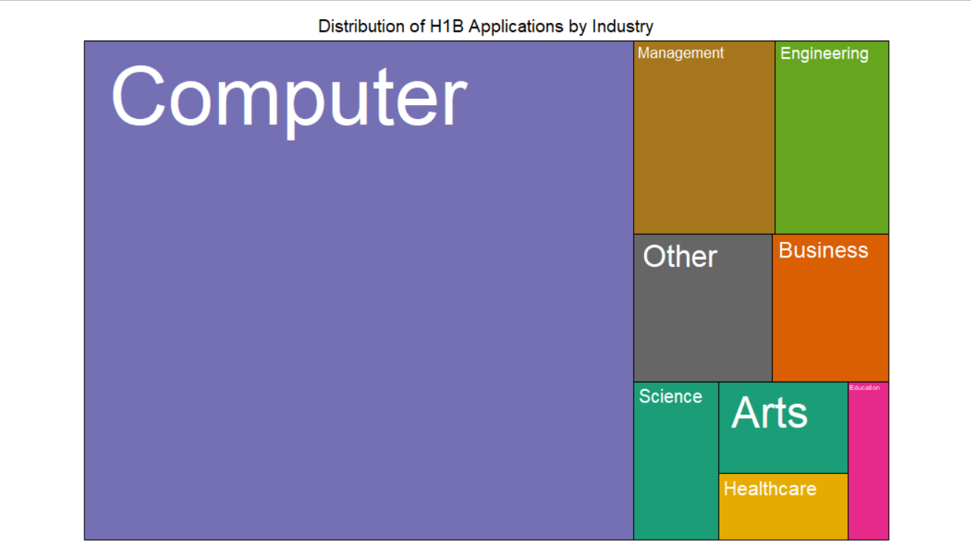



# **EXPLORATORY ANALYSIS**

Once preprocessing was performed, the rate of **Denied was discovered to be 1.3% of the dataset**. In addition, this report will explore the relationship between different variables, and how those interactions impact the approval outcome of the application. However, because the data is almost entirely categorical, a traditional correlation plot was not very useful for visual exploration.

The below chart shows boxplots which demonstrate the difference in salary between part time and full time employees. The Y axis simply describes the offset of the boxplots and can be ignored. It can be concluded that full time work has a wide range of values, while part-time work has a narrower range. In addition it can be seen that industries have significantly different outcomes on average wages.

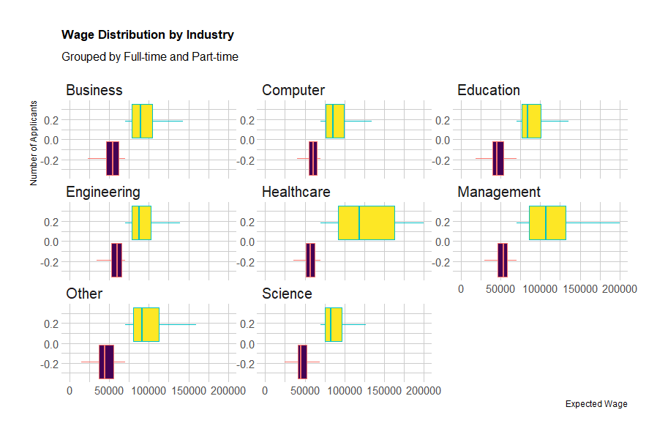

The below chart presents the same information from above in an alternative format. From this view, the Y axis shows the count of workers and the X axis shows their wages. This graph displays the relationship and volume of full time to part time workers.

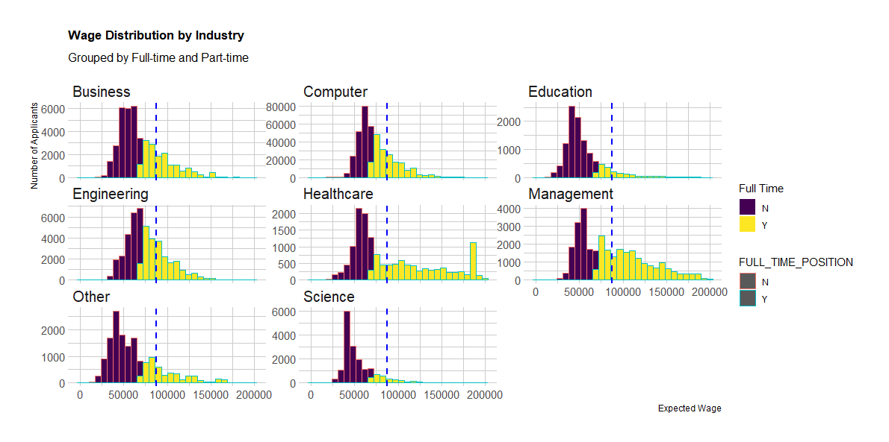



In the following chart the overall salary is compared by region and category. While the “Other” category for location varies wildly by salary, it is worth noting that the number of records from locations outside the continental United States was very small, and is prone to suffer from insufficient data. From this chart, it is clear that the region has a moderate influence on wage for certain categories of work. For example, 75% of computer jobs in the west pay more than the median wage for computer work in other regions. Another finding is that healthcare workers in the South have a wider range of high paying jobs than healthcare workers from other regions. A final result is that Science workers make decidedly less money working in the midwest than their counterparts in other regions.

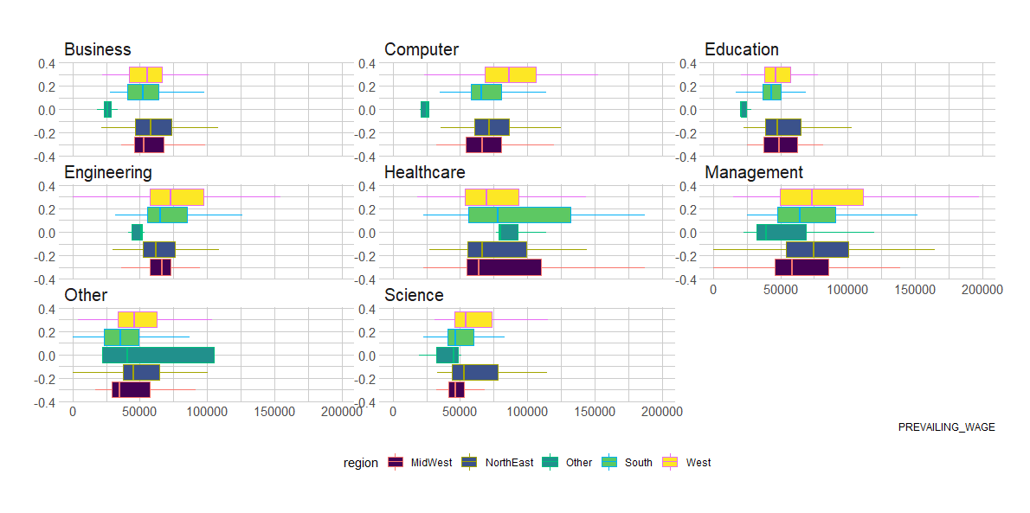

This report seeks to analyze the factors that have the greatest impact on application denial. The lower chart shows bar charts by the percentage of denial. The data shows that Computer is the working category with a significantly lower percentage of rejections at just under 1%. Meanwhile, “Other” work category has a far higher percentage of rejection than all other categories.

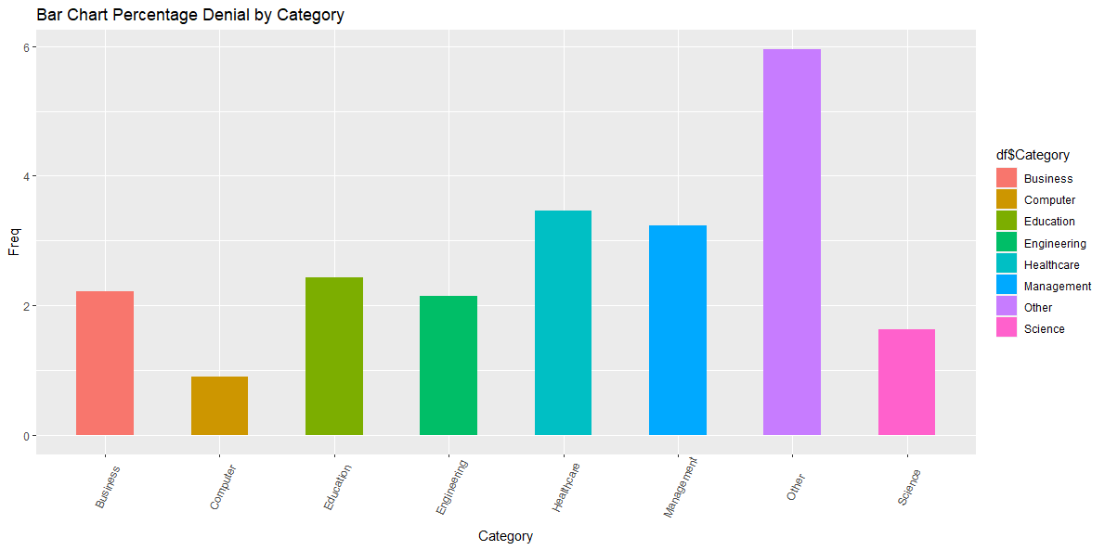

After examining the relationship between region and denial, it is clear that workers outside of the mainland United States suffer a far greater risk of denied applications.

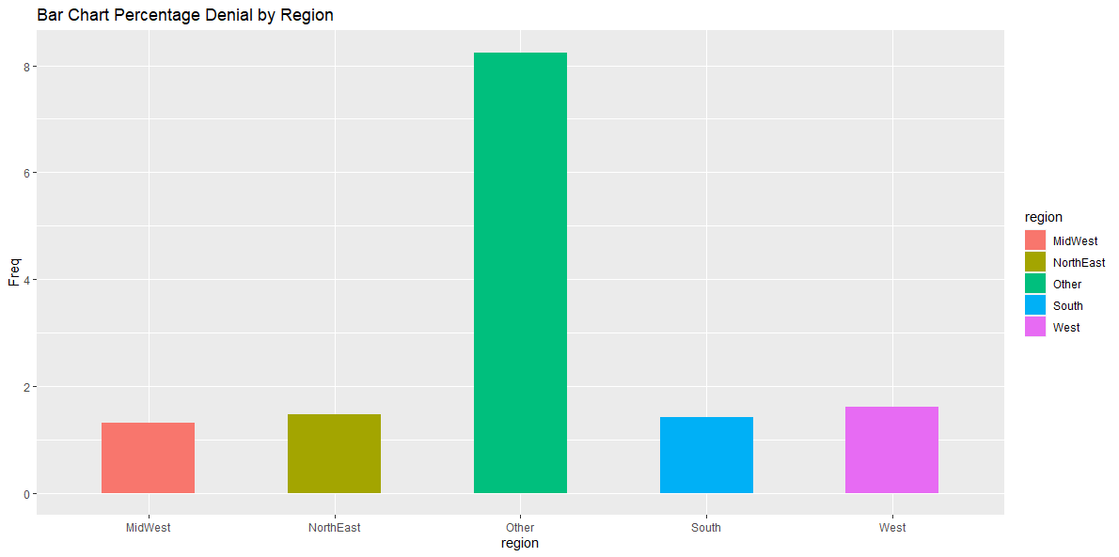

By analysing the distribution of applicants over different ranges of prevailing wage, we can see that the majority of applicants are within the medium prevailing wage range of 60k-100k.

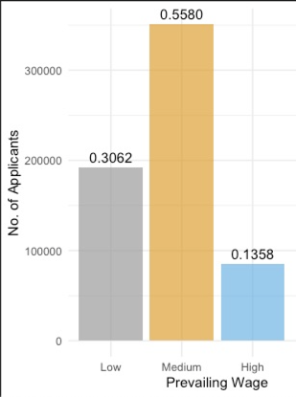



# **DATA MINING METHODS**

After completing all the exploratory analysis and preprocessing of the data, The predictor selected for producing models using different algorithms are: **FULL_TIME_POSITION, PREVAILING_WAGE, lon, lat, STATUS, Category.**

* **KNN, Classification Tree, Neural Net** which are Machine learning data-driven techniques and are non parametric method, as no assumption is made and no parameters are evaluated
* **Logistic regression**: Model driven and assumption based supervised learning technique used only for classifying categorical variables.
* The performance (accuracy) of all the models are checked by using the validation data.

## 6.1 MODELS WITH ORIGINAL DATASET

### 6.1.1. KNN

Dummies are created for the Categorical variable “Category” and all other numerical variables have been normalized using the preprocess() function to achieve the same order of magnitude.

To find the best k, the model is trained on normalized training data with k=1 to k=25.

From the below graph, it is observed that the optimal value of k should be considered as 5 because higher the value of K, it has more chances of losing local proximity and very small value of k will have an overfitting issue. So, with accuracy as 0.9854 and from k=7 onwards the accuracy is not changing very much. Thus,k = 5 is selected.

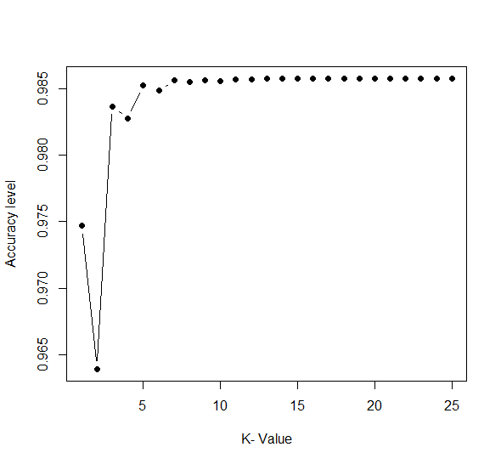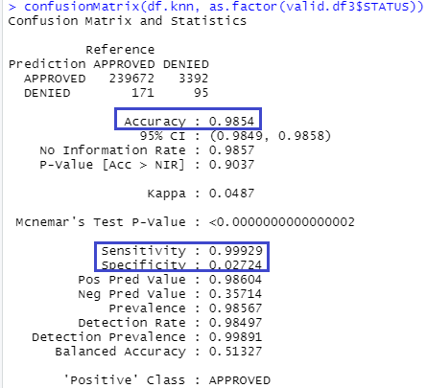

 

Finally, the model is trained with k=5 and tested with validation data. The accuracy on validation data is 98.54%. As the model has selected the positive class as APPROVED cases, accuracy of predicting **APPROVED cases (Sensitivity) is 99.92%** but predicting **DENIED cases(Specificity) is very low 2.72%** only. This means that there are high chances that the model will falsely select the DENIED case as APPROVED case. Hence, this model is not suitable for prediction and it is required to develop another model.

### 6.1.2. CLASSIFICATION TREE

The classification Tree is developed in 3 steps to classify the status as 1(Approve) and 0(Denied). The tree steps were:

* **Default Tree:** To explore and understand the Status classification without any specific control on the tree formation. The **Accuracy** for this default tree is **98.6%** with Specificity (Accuracy for Denied cases) as 0% and sensitivity(Accuracy for Approve cases) as **100%**.
* **Pruned Tree:** In the next Tree, the Default tree was pruned by finding the best cp with least x-error to get a better tree with improved accuracy.

For cp =0.00052, the **Accuracy** for Pruned tree is **98.6%** withSpecificity (Accuracy for Denied cases) as 1% and Sensitivity(Accuracy for Approve cases) as **100%**. Refer below the Pruned Tree with Confusion Matrix and Statistics for the same.

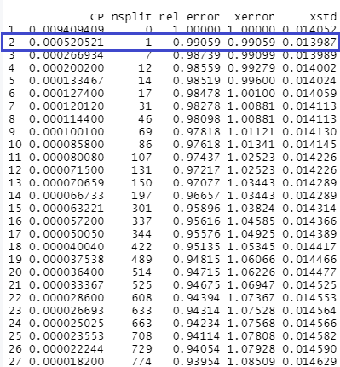 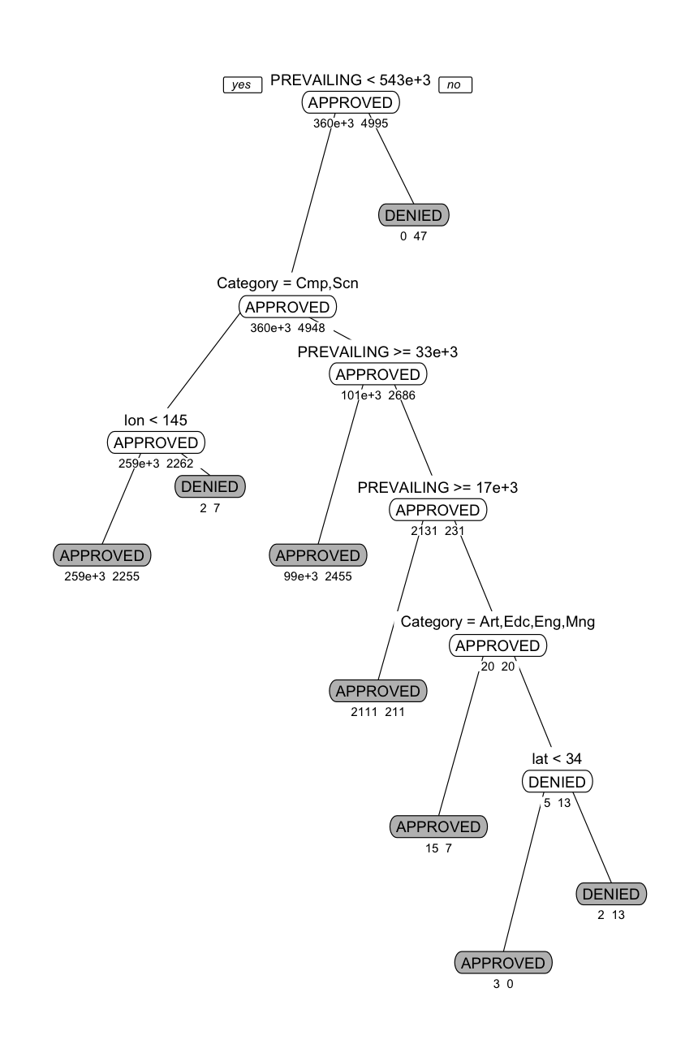 

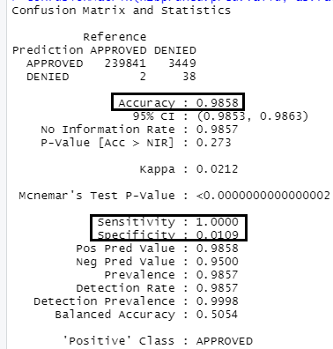 

* **Random Forest:** After the Pruned tree, Random Forest is developed for 100 trees to find the predictors that contribute more to the classification of Status and Variable Importance Plot is made from Plot, it can be seen that **Category is the highest contributor** and appears in the maximum of trees for the classification(Refer below).

The **Accuracy** for Random Forest is **98.6%** with Specificity (Accuracy for Denied cases) as **3%** and Sensitivity(Accuracy for Approve cases) as **99.94%**.

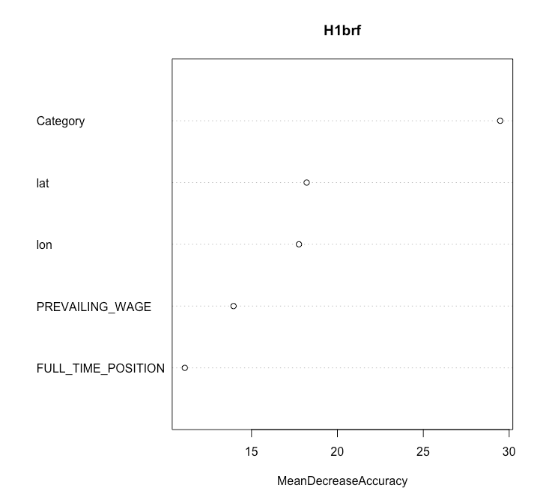



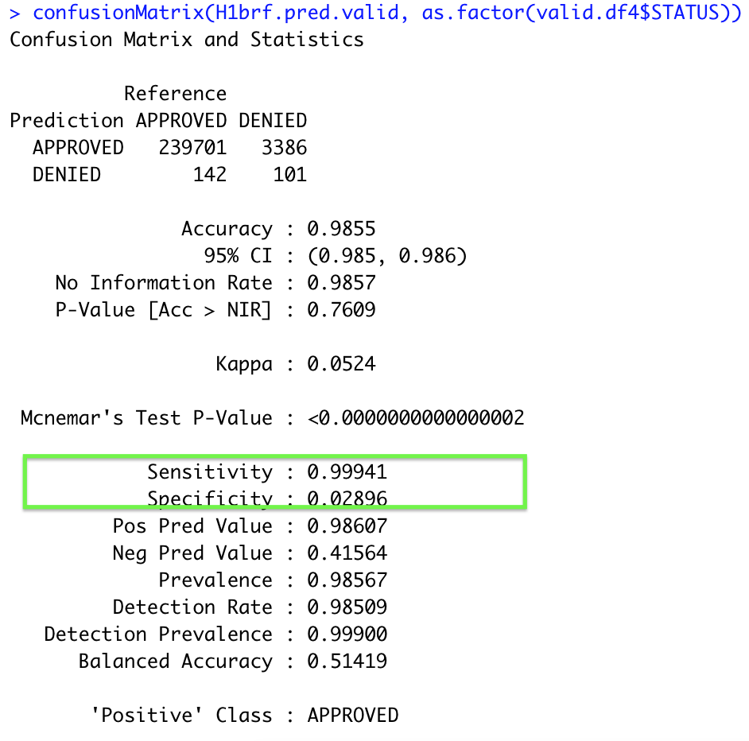

The Accuracy, Sensitivity and Specificity is similar for all the three steps with marginal improvement in Sensitivity (Accuracy for Denied cases) for Pruned Tree and Random Forest. Considering business application, where visa application is filed with application fees and for every denial status its a loss. As the Classification Tree is very low on accuracy (3%) for classification of denial cases, some better models shall be developed with higher accuracy for Denial Cases classification.

### 6.1.3. LOGISTIC REGRESSION

The variables “Category” and “Status” are changed to class factor before models are created. The result of the logistic regression model (Fig 6.1.3(a)) shows that the model will correctly predict the **approved cases** for **99.99% (specificity)**of the time but will perform quite miserably for the **denied case** with only **1% (sensitivity)** time being correct. **Total accuracy is 98.58%** for the Model. The analysis is done by taking the probability as 0.9 which means that the model will say a case will be approved only when it is 90% sure (an effort to deal with the bias-ness of the dataset).

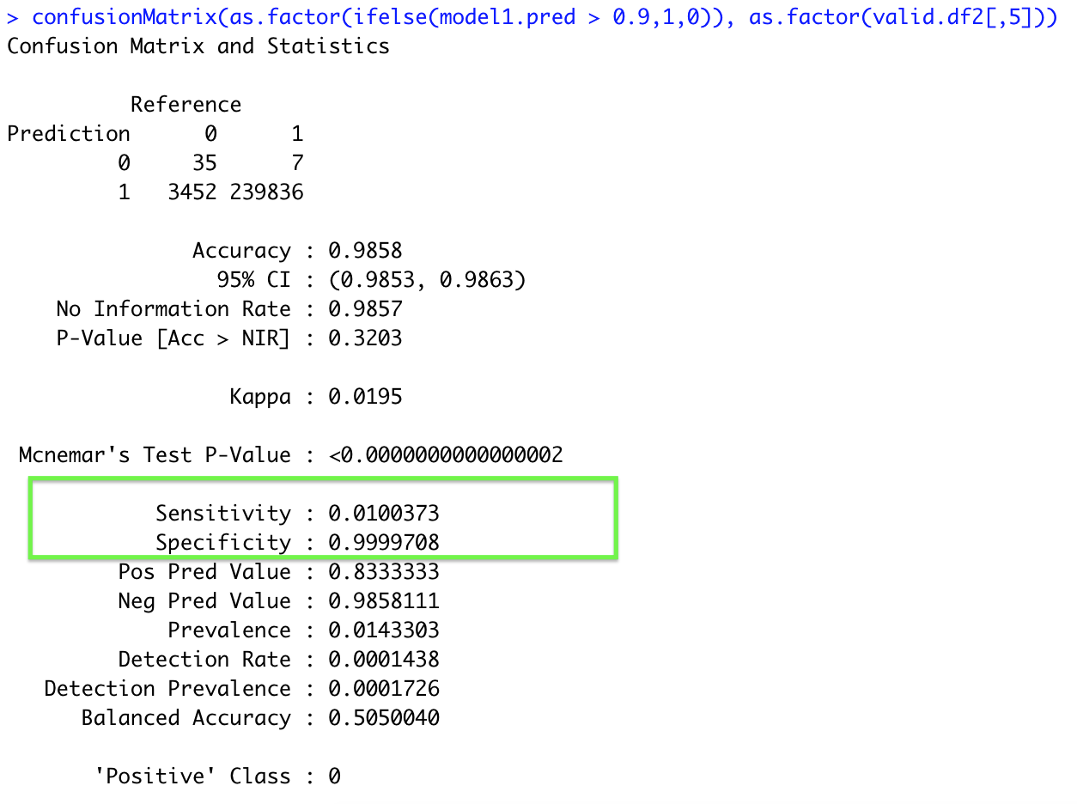



From the summary of the logistic model(Fig 6.1.3(b)), it is clear that the probability of getting an H1B application approved is lowest in the category “**Other**” as the Coefficient for “**Other**” is negative(**-0.0063**). The probability is also showing a negative relationship with “PREVAILING_WAGE” because there are a lot of outliers in PREVAILING_WAGE with a lot of extreme high wages being denied. Also the probability of getting H1B increases as the latitude increases and increases as the longitude decreases, thus indicating the region where most of the H1B applications are approved.

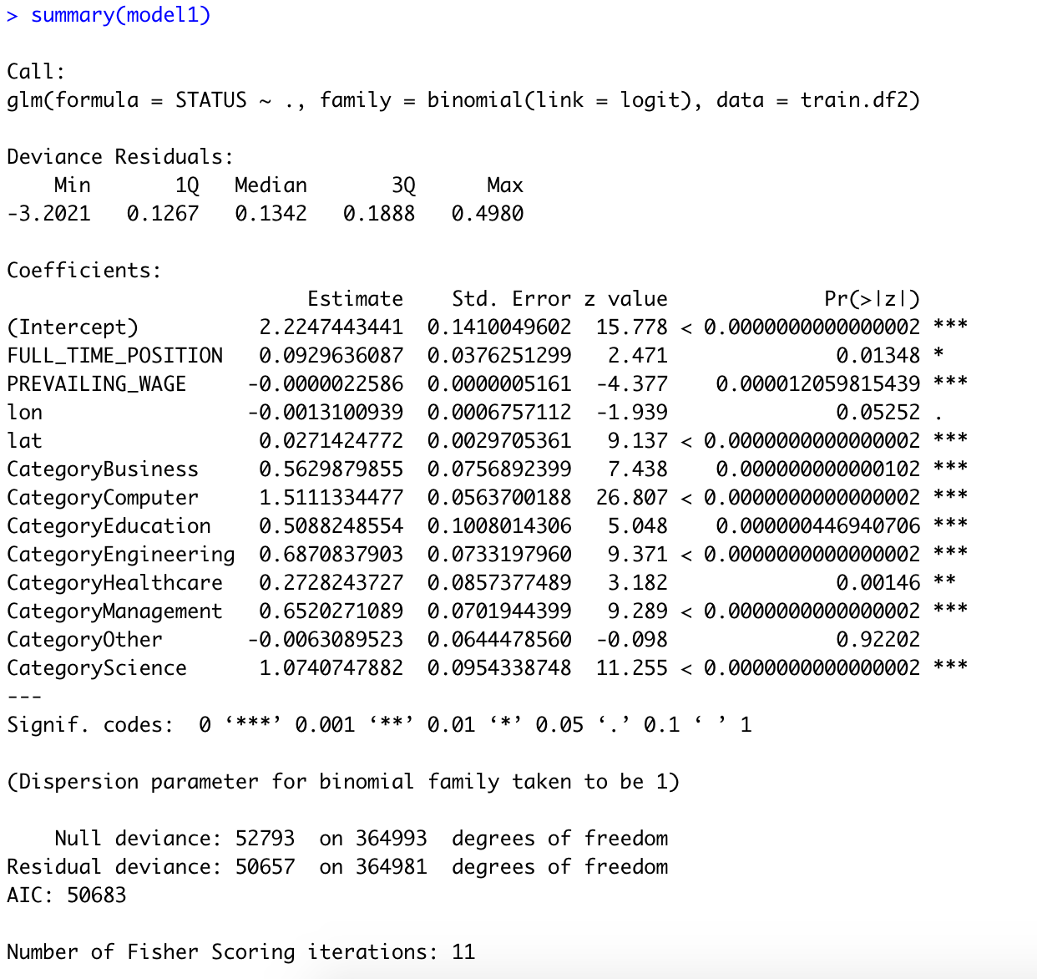



### 6.1.4. NEURAL NETWORK

Dummies are created for “Categories” and “STATUS” then in pre-processing the scaling of the continuous variable: “PREVAILING_WAGE”, “lon”, “lat”, are done before creating the models. Neural Net Model can be seen in Fig 6.1.4(a). Hidden layer 1 with 3 nodes is used in producing the NN model.

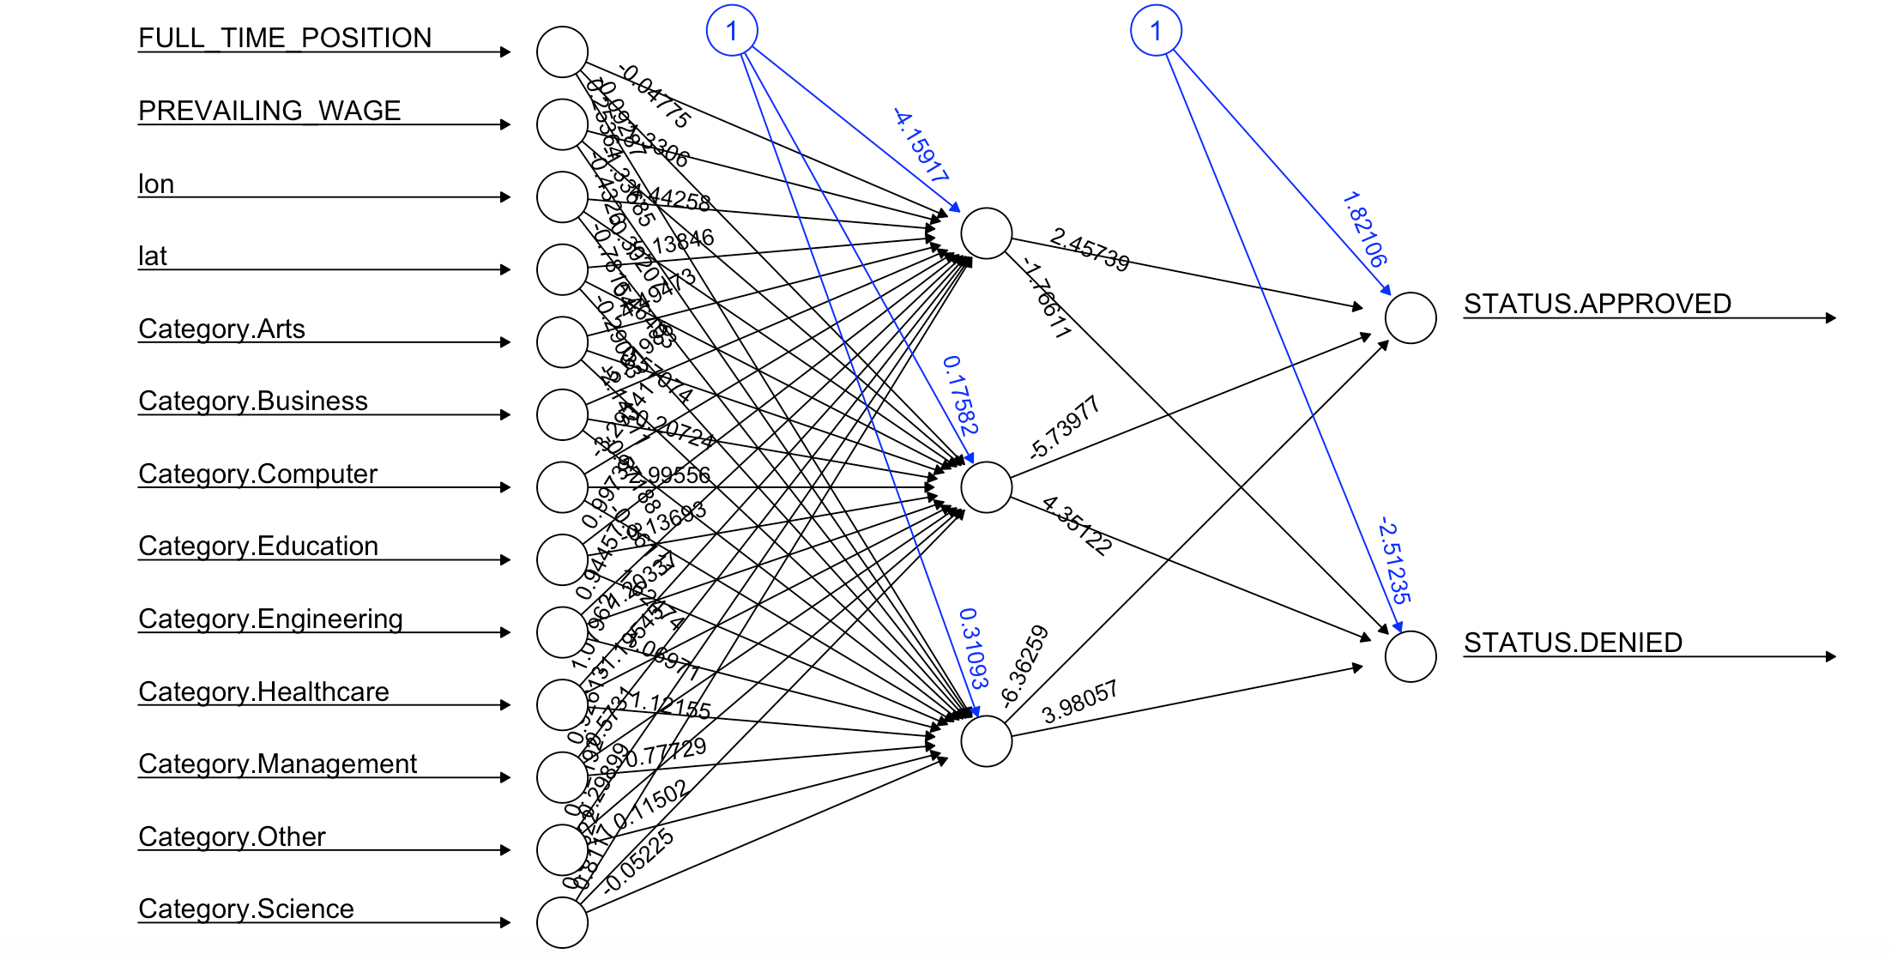

The neural net model (Fig 6.1.4(b)) shows that it is doing comparatively well in predicting the **denied cases** with the performance of **13.96%(sensitivity)**, which is remarkably higher than what other Models have performed. Performance for **approved cases** is **98.59% (specificity)** and the total **accuracy** of the model is **98.41%**. The analysis is done by taking the probability as 0.9 which means that the model will say a case will be approved only when it is 90% sure (an effort to deal with the bias-ness of the dataset).

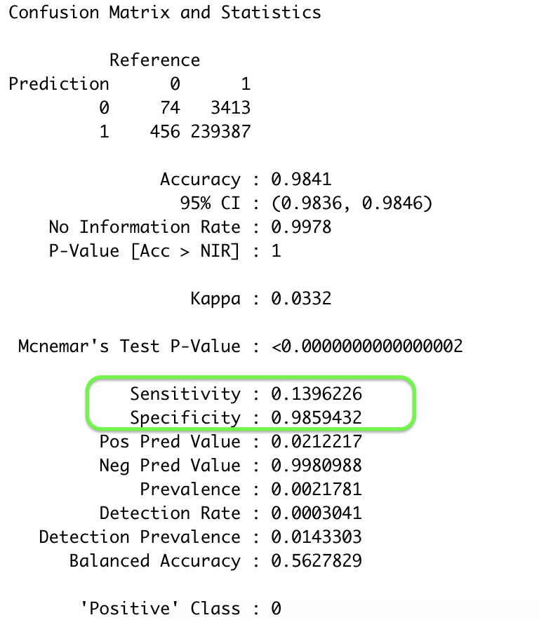



## 6.2 MODELS WITH UNDERSAMPLED DATASET

New models were created with undersampling to account for the imbalance in the dataset. To do this, a high number of Approved cases were left out of the training set to create a more even ratio between the original **98.7%** Approved and **1.3%** Denied cases. It was hoped that this new model would perform better with real world data than the previous models were capable of. The new dataset dimension changed to **28,304** records with **30%** of the data consisting of denied cases.

### 6.2.1. KNN

After pre-processing, the model was developed with the undersampled dataset using k=19 (highest accuracy and taking local structure in consideration)(Fig 6.2.1(a)).

The chances of correctly predicting the denied case by using the KNN algorithm with the undersampled dataset is increased to **27.67%** . Although the overall accuracy is reduced to **71.82%** and the performance for approved cases is reduced to **91.11%** but still the model is quite realistic from the perspective of denied cases (Fig 6.2.1(b)).

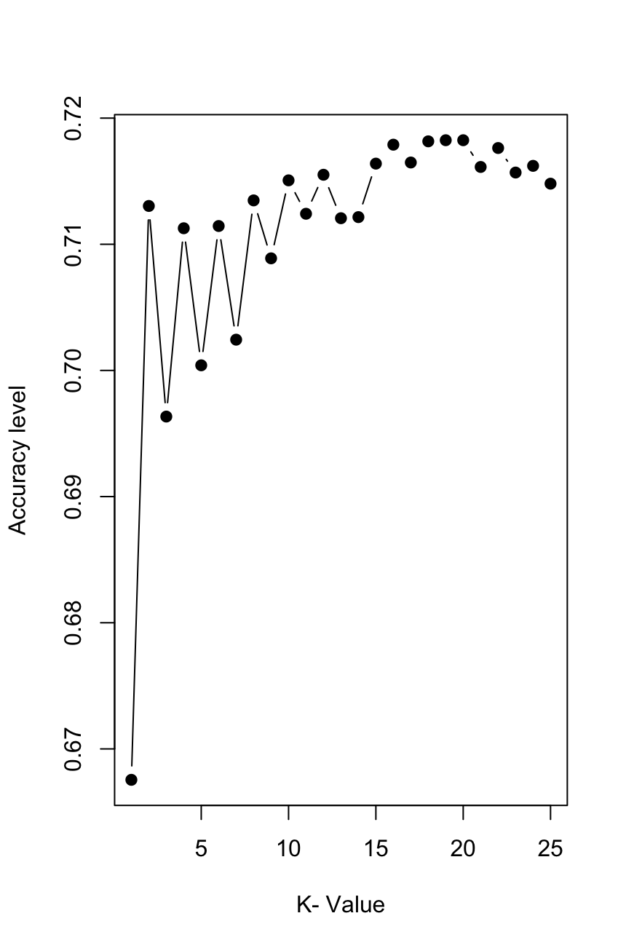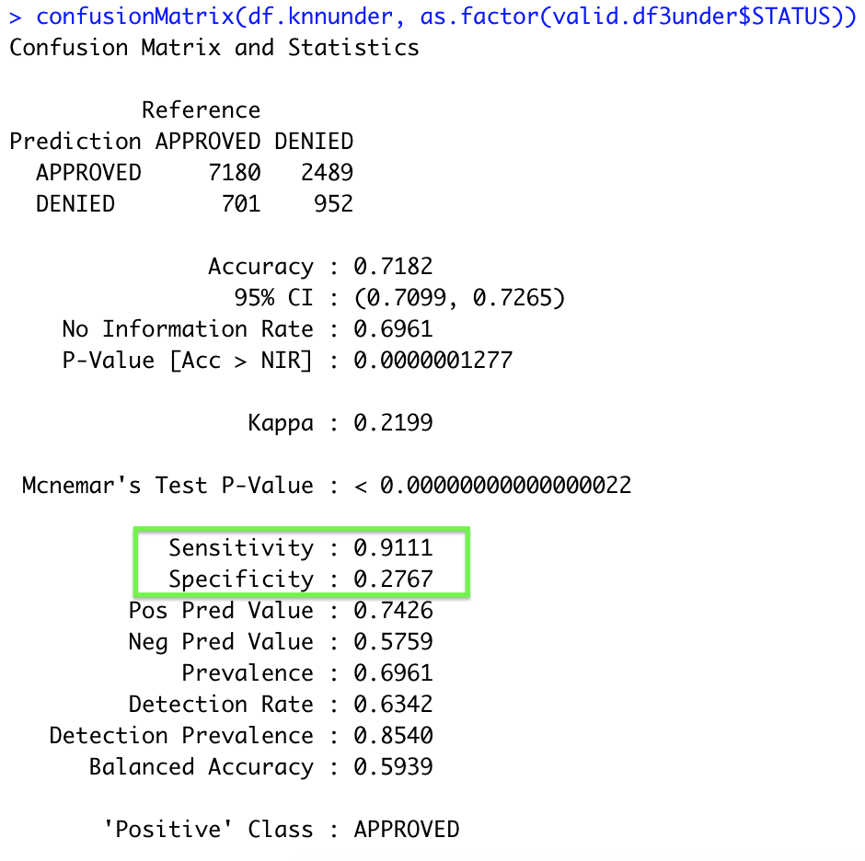



### 6.2.2. CLASSIFICATION TREE

The pruned tree looks very specific to come up with different rules for the status classification. For example:

IF “Category” <> “Computers” or “Science” AND “PREVILING_WAGE” < 40000 THEN Class(DENIED).

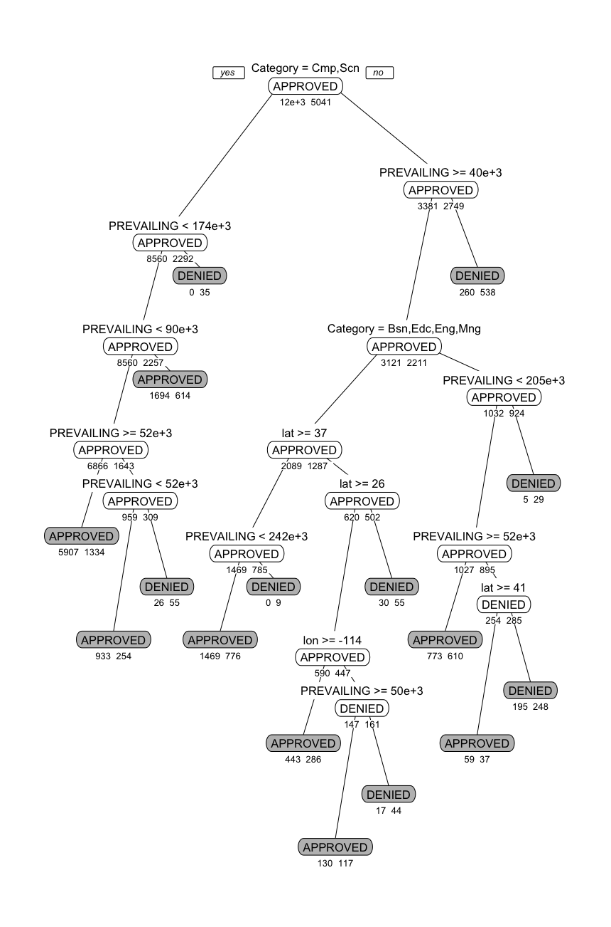



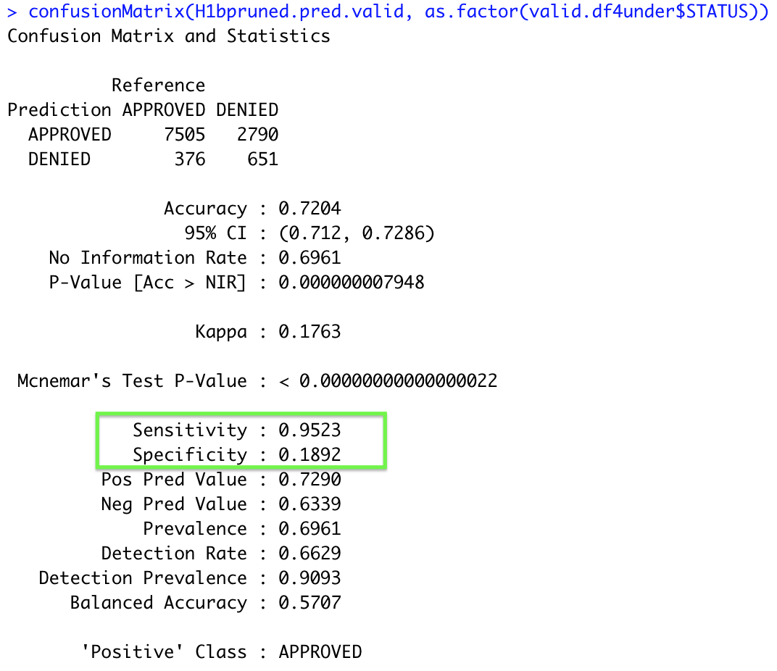



**Random Forest:**

With the undersampled data, Random Forest Fig 6.2.2(d) shows an improvement in classifying the denied cases to **31.3%** as compared to earlier models. The overall model accuracy is **72.4%** with prediction accuracy of approved cases as **95.23%**. With these accuracy measures, it can be concluded that there is considerable improvement in model applicability to the real world.

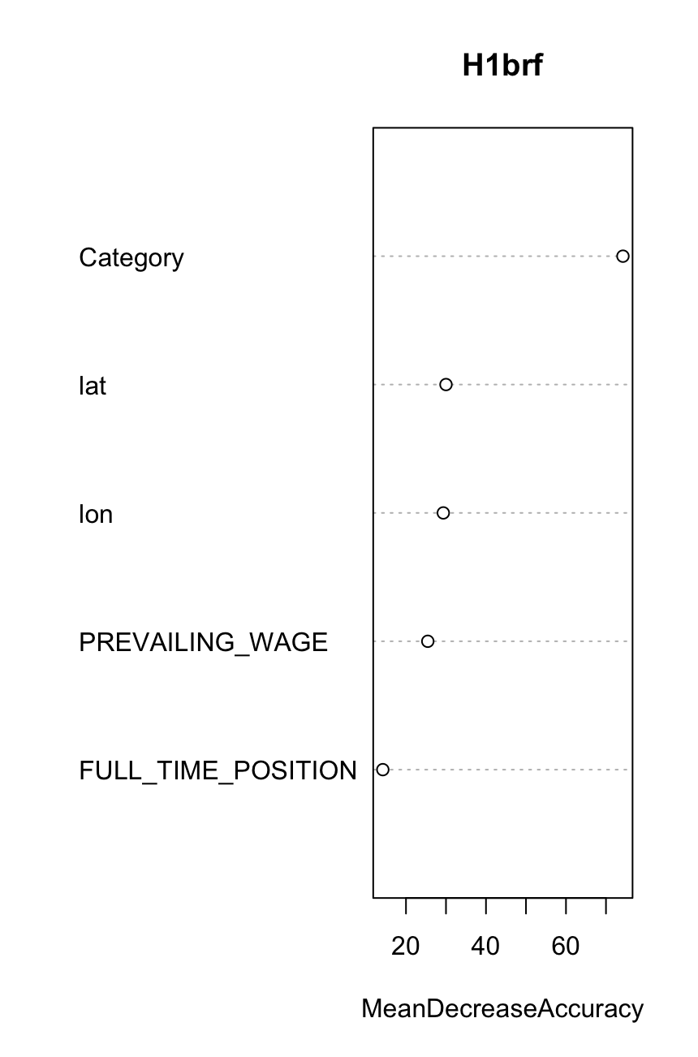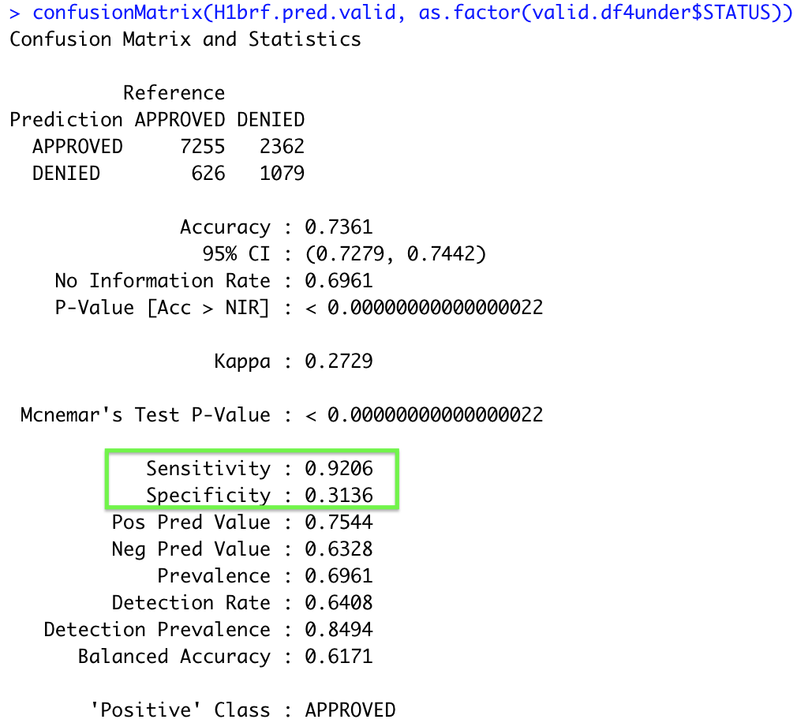



### 6.2.3. LOGISTIC REGRESSION

In the logistic regression model the accuracy of predicting the denied cases is increased to **24.38%** versus ~ **1%** for the original dataset model(Fig 6.2.3(a)). The overall model accuracy is **71.16%** and approval cases prediction accuracy is **91.59%** which is relatively good for a model applicability.

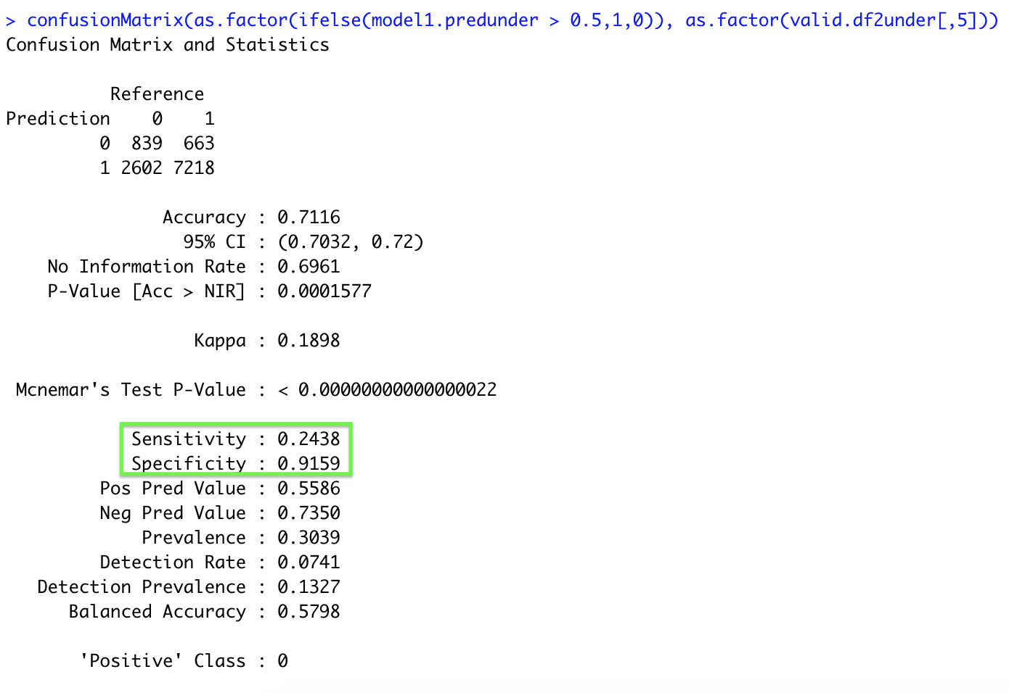



The relation between the predictors and the probability of getting an H1B application getting approved remained the same(based on the nature of coefficients of the predictors)(Fig 6.2.3(b)).

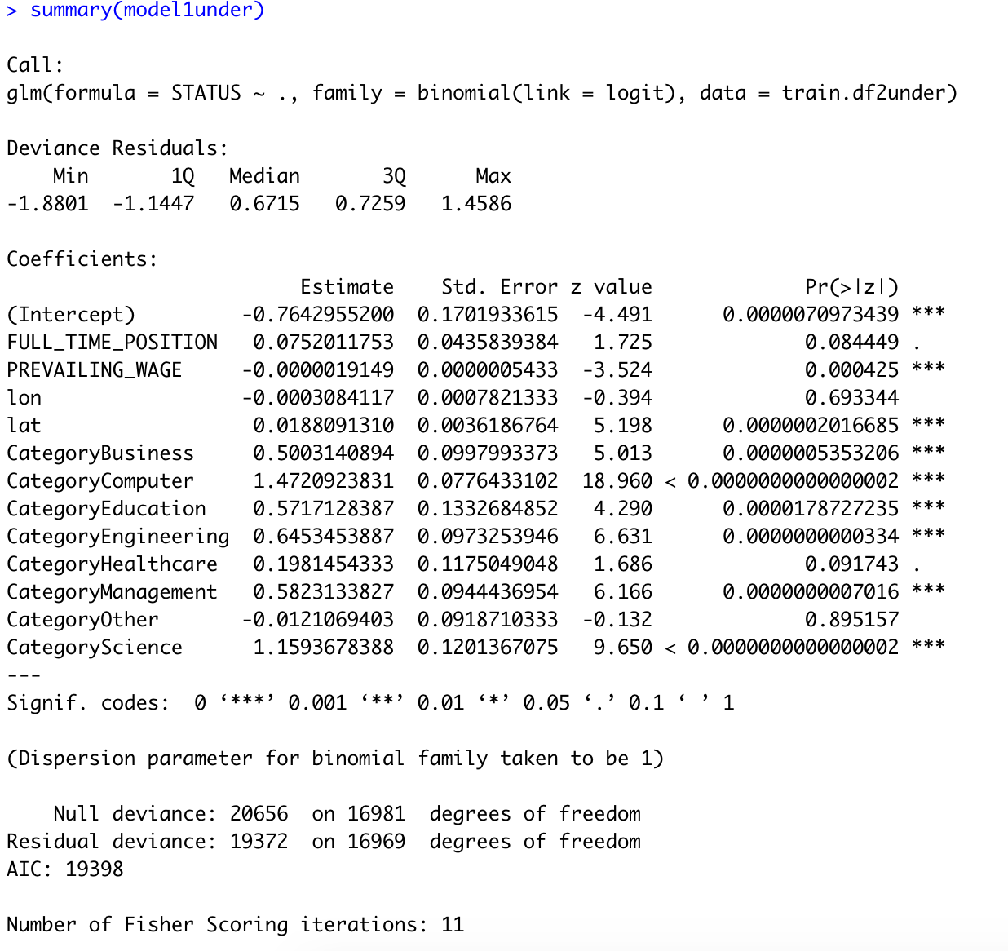

### 

### 6.2.4. NEURAL NETWORK

With the neural network method, the accuracy of predicting the denied cases is also remarkably increased by four times from **13.96%** with original dataset to **57.86%** with undersampling technique. Hidden layer 1 with 3 nodes is used in producing the NN model.

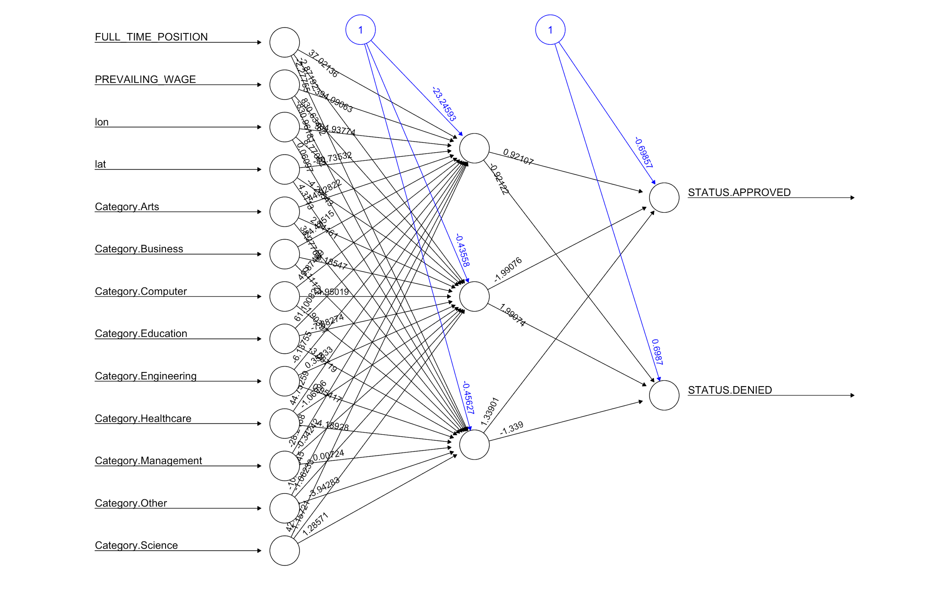



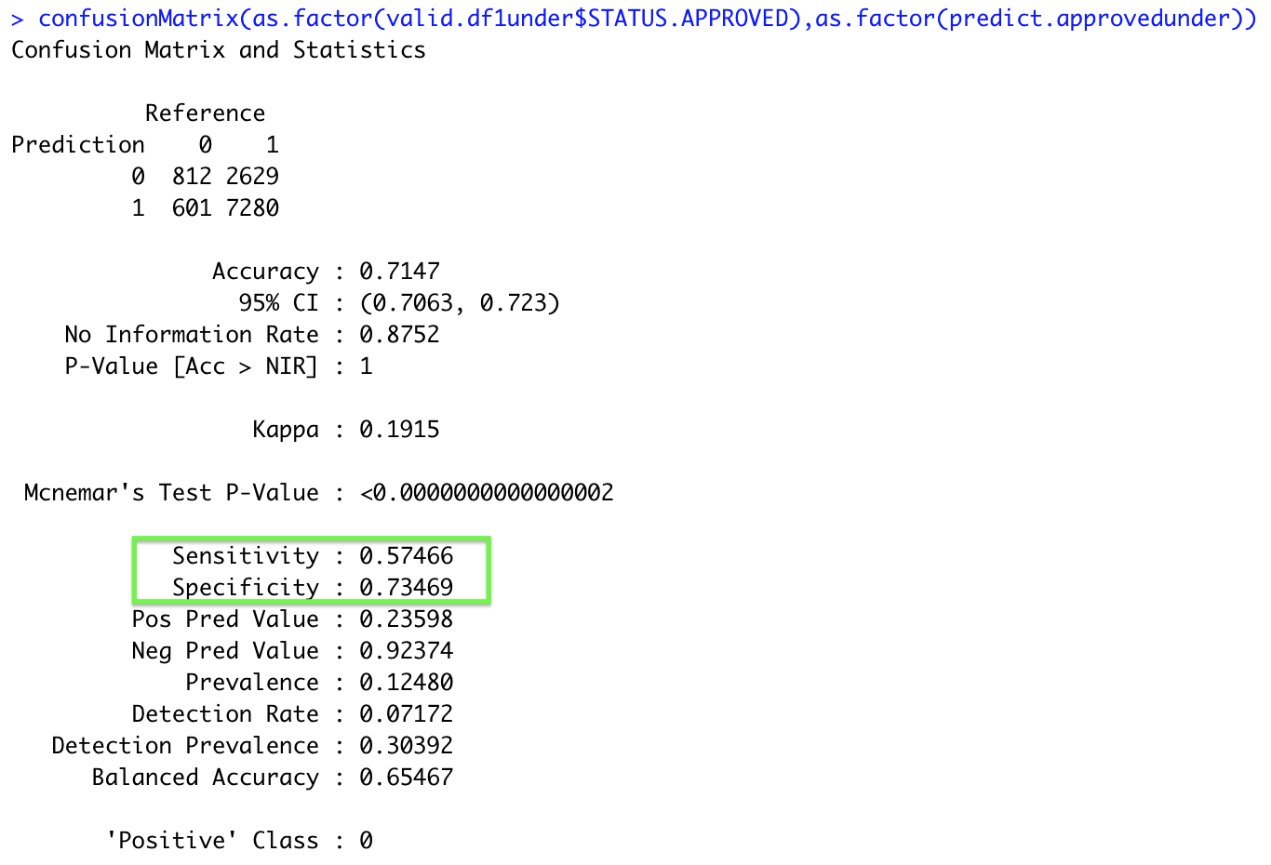

# COMPARISON OF MODELS

After implementing selected algorithms to the original and undersampled dataset, different models were created. The comparison of those models based on accuracy measures (for validation data) are presented in table 7.1.

|  |  |  |  |  |  |
| --- | --- | --- | --- | --- | --- |
|  | **Accuracy Measures** | **KNN K=5** | **Classification Tree (Random Forest)** | **Logistic Regression** | **Neural Net Nodes = 3** |
| Model Accuracy% | 98.54 | 98.55 | 98.58 | **98.41** |
| Chances of Correctly Predicting a Approved case(%) | 99.92 | 99.94 | 99.99 | **98.59** |
| Chances of Correctly Predicting a Denied case(%) | 2.72 | 2.9 | 1 | **13.96** |
|  | **Accuracy Measures** | **KNN K=19** | **Classification Tree (Random Forest)** | **Logistic Regression** | **Neural Net Nodes = 3** |
| Model Accuracy% | 71.82 | 73.61 | 71.16 | **71.47** |
| Chances of Correctly Predicting a Approved case(%) | 91.11 | 92.06 | 91.59 | **73.47** |
| Chances of Correctly Predicting a Denied case(%) | 27.67 | 31.36 | 24.38 | **57.47** |



This project’s primary purpose is to correctly predict denied cases. The penalty for failing at that task will be a financial one for the applicant companies, the applicant workers, and our own consultancy firm.

Comparing the result of the Models produced:

1. Based on the original dataset:

From Table 7.1, it is clear that the neural net model is the best for predicting the denied case(**13.96%**). Overall model accuracy (**98%**) and it’s accuracy for predicting the approved case(**98.59%**) is comparable to all the other models using the original dataset.

1. Based on the undersampled dataset:

Using the undersampled dataset, the neural network model bests all other models with an achieved accuracy of **57.47%**. This is despite the fact that the NN achieves the lowest accuracy for predicting approved cases(**73.47%**). However, because the primary objective is to correctly predict denied cases, this is the best model to be used in real time to predict both the Case Status outcomes.

1. Comparing selected models from the Original dataset and the undersampled dataset:

From the findings above, this report can conclude that the undersampled neural net model has a lower general prediction accuracy, but higher prediction accuracy for denied cases. Because the main objective is to accurately predict denied cases, the undersampled neural network is the best model for real world applications.

# CONCLUSION AND RECOMMENDATION

While this dataset is a rich environment for exploratory analysis, it challenges many of the traditional algorithms for prediction. However, once undersampling was performed, a comparison of accuracies proves that the method grants higher prediction quality for Denied cases. Undersampling also allows this report to claim that a more balanced dataset would have allowed greater overall accuracy than an imbalanced dataset.

A company that is able to spare clients the time and cost of failed applications would bring in a lot of customers. That business could use this report’s model to aid in consulting clients with their H1-b applications, using it to quickly and accurately predict the outcome of their current application, and revising it to have a higher chance of being accepted.

# FUTURE WORK

If granted more time, additional models could be devised from the existing data. For example, early trials with variables derived from existing data allowed for overall prediction accuracy approaching 99%, with correct prediction of denied cases at nearly 60% and correct prediction of accepted cases at over 99%. Using these techniques and expanding their functionality could have led to far better results than what the project’s time frame allowed for.

Furthermore, clustering algorithms could be performed on the variables State or Industry, and then the analysis can be done on different clusters separately. By using clustering and undersampling together, significantly more accurate results could be achieved.

# REFERENCES

1. Galit Shmueli, Peter C. Bruce, Inbal Yahav, Nitin R. Patel, Kenneth C. Lichtendhl Jr. Data Mining for Business Analytics Edition 2018
2. H. Wickham. **ggplot2**: Elegant Graphics for Data Analysis. Springer-Verlag New York, 2016
3. <https://www.rdocumentation.org/>
4. R Core Team (2020). R: A language and environment for statistical computing. R Foundation for Statistical Computing, Vienna, Austria. URL [https://www.R-project.org/](https://www.r-project.org/).
5. Nicola Lunardon, Giovanna Menardi, and Nicola Torelli (2014). **ROSE**: a Package for Binary Imbalanced Learning. R Journal, 6(1), 82-92.
6. Dean Attali and Christopher Baker (2019). **ggExtra**: Add Marginal Histograms to 'ggplot2', and More 'ggplot2' Enhancements. R package version 0.9. [https://CRAN.R-project.org/package=ggExtra](https://cran.r-project.org/package=ggExtra)
7. Bob Rudis (2020). **hrbrthemes**: Additional Themes, Theme Components and Utilities for 'ggplot2'. R package version 0.8.0. [https://CRAN.R-project.org/package=hrbrthemes](https://cran.r-project.org/package=hrbrthemes)
8. [www.google.com](http://www.google.com)